**PS Traverse Utility**

**Purpose** :

Traverses Product Structure and reports BOM line in to a file in specified delimited format.

**Environment** :

Windows 7

**Prerequisite:**

* Input file contains list of Item Ids and its revision delimited by semi-colon (;)



* Output Folder – Empty Output folder where the BOM and log files will be created.
* Create Configuration file with following details.
  + Attributes list for BOM Line and Item Revision.
    - Note : For BOM Line attributes list the display name of the columns.
  + Delimiter
  + Optional : relstate, newowner and group

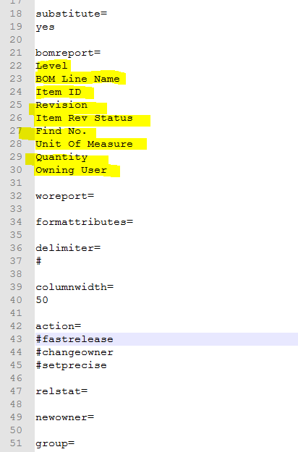

* PS Traverse batch file – Batch files generates BOM and Log files.
* Update Revision Rule in Batch File, if needed.

**Execution Procedure:**

* Copy Input, Config and Batch file from SVN into a folder.
  + input.txt
  + config.txt
  + BOM_Export.bat
* Open Windows Command Prompt.
* Go to the folder (in cmd ) where batch file is located.
  + CMD >>cd /d “folder location”
* Run “BOM_Export.bat” Batch file. It will ask for the following,
  + TC_ROOT - TC Root Folder
  + TC_DATA - TC Root Folder
    - Note : After this tc_profilevars will be executed automatically.
  + TC User Id – Teamcenter User ID
  + TC Password - Teamcenter User Password
  + TC Group – Teamcenter User Group
  + Input File Name ( Name including Full Path )
  + Output Folder ( Full Path )
    - Note : Output folder should exist.

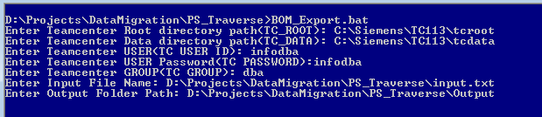

* Batch file generates BOM for all Items listed in input file saves them in Output directory along with log files.
  + BOM File : 000041_A_BOM.txt
  + Log File : 000041_A_Exp_log

Note :

If the batch file is executed from Teamcenter Command Prompt, TC Root, TC Data will be set automatically.

**Output**:

